CS 499 Module One Assignment Template

Complete this template by replacing the bracketed text with the relevant information.

- Self-Introduction: Address all of the following questions to introduce yourself.

  - How long have you been in the Computer Science program?
I have been in the Computer Science program since 2023.

  - What have you learned while in the program? List three of the most important concepts or skills you have learned.
I have learned to understand different programming languages and recognize both their similarities and differences. I also learned about different paths and roles within the computer science field and gained a deeper understanding of what they involve and how to properly handle the tasks required for them. The three most important skills I learned were becoming more observant and goal orientated so I can fully understand what is being asked of me by carefully reading and taking my time to process the requirements, learning how to code and properly test my work to identify and fix issues more efficiently and developing strong security awareness so the code I build does not contain vulnerabilities that could be exploited or could expose private data.

  - Discuss the specific skills you aim to demonstrate through your enhancements to reach each of the course outcomes.
The skills I aim to demonstrate for the enhancements I will be making to reach the course outcome would be able to have the designs be simpler for either the users or admins working on the application while also having security in mind. This would include the code being more organized.

  - How do the specific skills you will demonstrate align with your career plans related to your degree?
The specific skills I want to demonstrate align with my degree by helping me become a better communicator and giving me a stronger understanding of what is needed to successfully develop a product that meets requirements and user expectations. These skills also relate to my ability to fully understand features, maintain security awareness, and produce organized and functional code that can be used effectively in future software engineering or product orientated roles.

  - How does this contribute to the specialization you are targeting for your career?
This specialization contributes well to my career goals because it adds many of the skills and responsibilities I believe are important for the roles I am targeting. I know I will need to work closely with colleagues and communicate effectively with business partners or stakeholders, so it is essential to be a critical thinker and carefully analyze what is expected from me to make good decisions regarding timeliness features, and development priorities. It also helps me understand the importance of writing relevant and efficient code, following best practices for design, and keeping the organization’s security and overall goals in mind to remain an asset to the team.

- ePortfolio Set Up:

  - Submit a screen capture of your ePortfolio GitHub Pages home page that clearly shows your URL.
    - You already have a repository in GitHub where you uploaded projects in previous courses. Your ePortfolio will reside in GitHub but can link to work at other sites, such as Bitbucket.

  - Use the GitHub Pages link in the Resource section for directions on:
    - How to create your GitHub website and publish code to GitHub Pages
    - Issues, such as adding links to other sites

  - Paste a screenshot of your GitHub Pages home page with your URL clearly showing in the space below.

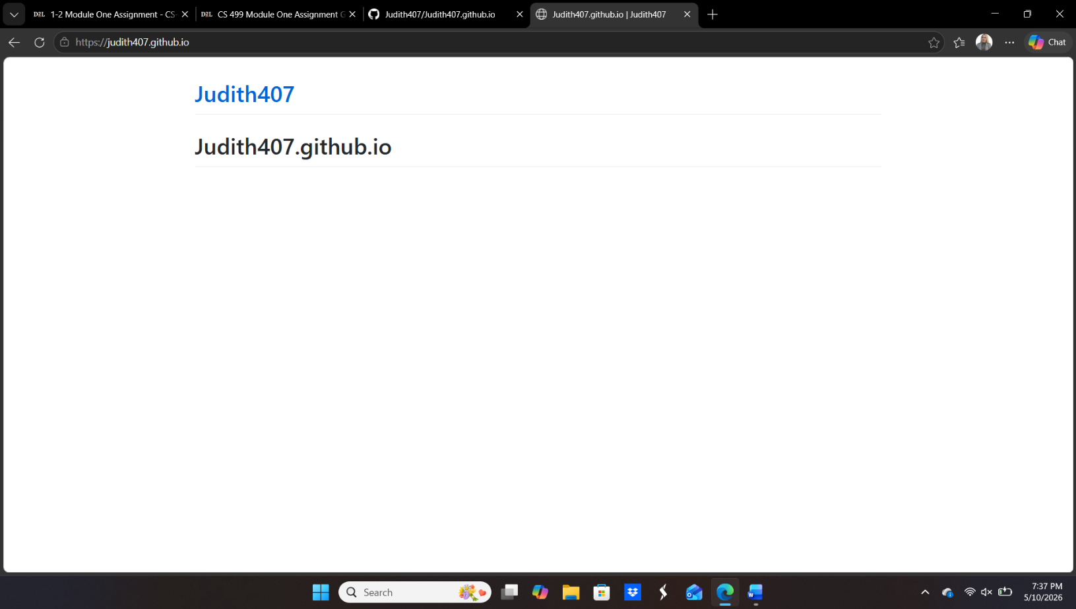

- Enhancement Plan:

  - Category One: Software Engineering and Design
    - Select an artifact that is aligned with the software engineering and design category and explain its origin. Submit a file containing the code for the artifact you choose with your enhancement plan.

The artifact I selected is my Travlr Getaways full-stack web application for my class CS-465, Full Stack Development. The project was built using the MEAN stack which meant using MongoDB, Express, Angular, and Node.js. The purpose of the application was to allow users to view travel packages while also allowing the administrators to manage and update the trip information through the admin side of the application.

Note: Your artifact may be work from the following courses:

- IT 145: Foundation in Application Development
- CS 250: Software Development Lifecycle
- CS 260: Data Structures and Algorithms
- IT 315: Object Oriented Analysis and Design
- CS 320: Software Testing, Automation, and Quality Assurance
- CS 330: Computational Graphics and Visualization
- CS 340: Advanced Programming Concepts
- CS 350: Emerging Systems Architectures and Technologies
- CS 360: Mobile Architecture and Programming
- IT 365: Operating Environments
- IT 380: Cybersecurity and Information Assurance
- CS 405: Secure Coding
- CS 410: Reverse Software engineering
- IT 340: Network and Telecommunication Management
- IT 380: Cybersecurity and Information Assurance

    - Describe a practical, well-illustrated plan for enhancement in alignment with the category, including a pseudocode or flowchart that illustrates the planned enhancement.

My plan for enhancing the Travl Getaways application is to improve the admin side by strengthening the authentication process, improving validation for the add and edit forms, and making the overall user experience more organized and reliable. The current application already includes login authentication and trip management features, but I want to enhance them further by improving security protections, organizing the code more efficiently, and providing clearer feedback to the user when actions succeed or fail.
Start
User opens Travlr Getaways admin page
System checks for valid JWT tokens
If token is not valid:
Redirect user to login page
If token is valid:
Allow access to trip management features
User selects add trip or edit trip
System validates input
If fields are incomplete or not valid:
Display validation errors
If form is valid:
Send authenticated API request
Server verifies token and processes request
If request succeeds:
Display success message
Update trip listing
If request fails:
Display error message
End

For this category of enhancement, consider improving a piece of software, transferring a project into a different language, reverse engineering a piece of software for a different operating system, or expanding a project’s complexity. These are just recommendations. Consider being creative and proposing an alternative enhancement to your instructor.

Think about what additions to include to complete the enhancement criteria in this category. Since one example option is to port to a new language, that is the kind of scale that is expected. This does not mean you need to port to a new language but instead have an equivalent scale of enhancement. Underlying expectations of any enhancement include fixing errors, debugging, and cleaning up comments, but these are not enhancements themselves.

    - Explain how the planned enhancement will demonstrate specific skills and align with course outcomes.

      - Identify and describe the specific skills you will demonstrate that align with the course outcome.

The specific skills I will demonstrate through this enhancement include authentication and security implementation, working with the frontend and backend integration, and improving user experience. I will also be organizing and maintaining the application code while improving validation and communication between the client and server.

      - Select one or more of the course outcomes below that your enhancement will align with.

My enhancement for this coursework aligns with Develop a security mindset that anticipates adversarial exploits in software architecture and designs to expose potential vulnerabilities, mitigate design flaws, and ensure privacy and enhanced security of data and resources.

Course Outcomes:

- Employ strategies for building collaborative environments that enable diverse audiences to support organizational decision-making in the field of computer science.
- Design, develop, and deliver professional-quality oral, written, and visual communications that are coherent, technically sound, and appropriately adapted to specific audiences and contexts.
- Design and evaluate computing solutions that solve a given problem using algorithmic principles and computer science practices and standards appropriate to its solution while managing the trade-offs involved in design choices.
- Demonstrate an ability to use well-founded and innovative techniques, skills, and tools in computing practices for the purpose of implementing computer solutions that deliver value and accomplish industry-specific goals.
- Develop a security mindset that anticipates adversarial exploits in software architecture and designs to expose potential vulnerabilities, mitigate design flaws, and ensure privacy and enhanced security of data and resources.

  - Category Two: Algorithms and Data Structures

- Select an artifact that is aligned with the algorithms and data structures category and explain its origin. Submit a file containing the code for the artifact you choose with your enhancement plan. You may choose work from the courses listed under Category One.

The artifact I selected is my Corner Grocer item-tracking program that was completed in CS-210 Programming Languages. The program was able to read item purchase data from a file, track how many times they were purchased, and display the information afterward through a menu.

- Describe a practical, well-illustrated plan for enhancement in alignment with the category, including a pseudocode or flowchart that illustrates the planned enhancement.

I plan to enhance my previous application by having it switch from arrays to mapping so it can search and count items more efficiently and faster.
Start
Create map to store item names and purchase count
Open input file
While file has items:
Read item from file
If item already exists in map:
Increase item count by 1
Else:
Add item to map with count set to 1
Close input file
Display menu options
If user searches for item:
Check map for item
Display purchase count
If user requests all items:
Display all item names and counts
If user requests histogram:
Display item name with matching number of asterisks
Save item data to backup file
End

For this category of enhancement, consider improving the efficiency of a project or expanding the complexity of the use of data structures and algorithms for your artifact. These are just recommendations. Consider being creative and proposing an alternative enhancement to your instructor. Note: You only need to choose one type of enhancement per category.

Think about what additions to include to complete the enhancement criteria in this category. Since one example option is to port to a new language, that is the kind of scale that is expected. Perhaps you might increase the efficiency and time complexity of an algorithm in an application and detail the logic of the increased time complexity. Remember, you do not need to port to a new language but instead have an equivalent scale of enhancement. Underlying expectations of any enhancement include fixing errors, debugging, and cleaning up comments, but these are not enhancements themselves.

- Explain how the planned enhancement will demonstrate specific skills and align with course outcomes.

  - Identify and describe the specific skills you will demonstrate to align with the course outcome.

The specific skills this will demonstrate aligns with course work since it allows it to search and update faster while maintain its core needs when locating the data.

  - Select one or more of the course outcomes listed under Category One that your enhancement will align with.

My enhancements best align with number three of the course outcomes, design and evaluate computing solutions that solve a given problem using algorithmic principles and computer science practices and standards appropriate to its solution while managing the trade-offs involved in design choices.
  - Category Three: Databases

    - Select an artifact that is aligned with the databases category and explain its origin. Submit a file containing the code for the artifact you choose with your enhancement plan. You may choose work from the courses listed under Category One.

The artifact I selected is my Grazioso Savare Dashboard for my class CS-340. Thue project used MongoDB and python to connect animal shelter data to an interactive dashboard where users could search and view records.

    - Describe a practical, well-illustrated plan for enhancement in alignment with the category, including a pseudocode or flowchart that illustrates the planned enhancement.

My plan for enhancing the Grazioso Salvare Dashboard is to improve security by removing hardcoded database credentials from the application and protecting sensitive login information more securely. I also want to improve the efficiency of searching records so the dashboard can process and display data faster while remaining easier to maintain as the database grows.
Start
Load secure database credentials from environment variables
Connect to MongoDB database
If connection fails:
Display connection error
Stop Program
If connection succeeds:
Allow dashboard access
User selects search or filter option
Send optimized query to database
Retrieve matching animal records
Display filtered results on dashboard
If user updates or adds record:
Validate data
Send CRUD request to database
Update dashboard results
Log errors securely without exposing credentials
End

For this category of enhancement, consider adding more advanced concepts of MySQL, incorporating data mining, creating a MongoDB interface with HTML/JavaScript, or building a full stack with a different programming language for your artifact. These are just recommendations; consider being creative and proposing an alternative enhancement to your instructor. Note: You only need to choose one type of enhancement per category.

Think about what additions to include to complete the enhancement criteria in this category. Since one example option is to port to a new language, that is the kind of scale that is expected. Perhaps you might increase the efficiency and time complexity of an algorithm in an application and detail the logic of the increased time complexity. Remember, you do not need to port to a new language but instead have an equivalent scale of enhancement. Underlying expectations of any enhancement include fixing errors, debugging, and cleaning up comments, but these are not enhancements themselves.
    - Explain how the planned enhancement will demonstrate specific skills and align with course outcomes.

      - Identify and describe the specific skills you will demonstrate that align with the course outcome.

The specific skills I will demonstrate would include securing sensitive information, organizing data so it can be managed better, and CRUD operations.

      - Select one or more of the course outcomes listed under Category One that your enhancement will align with.

The enhancements align best with number four, demonstrate an ability to use well-founded and innovative techniques, skills, and tools in computing practices for the purpose of implementing computer solutions that deliver value and accomplish industry-specific goals.
- ePortfolio Overall Skill Set

  - Accurately describe the skill set to be illustrated by the ePortfolio overall.
    - Skills and outcomes planned to be illustrated in the code review

The outcome I plan to illustrate for the code review is being able to communicate properly and explain the functionality of the applications, what improvements are needed, and how the enhancements would improve the overall application.

    - Skills and outcomes planned to be illustrated in the narratives

The skills I plan to illustrate are the steps I needed to take when enhancing my applications and the process I went through to overcome technical issues and successfully implement the changes.

    - Skills and outcomes planned to be illustrated in the professional self-assessment

The outcome I plan to illustrate for the professional self-assessment is by being able to determine where I am stronger and weaker so that I can continue to grow and improve while knowing how to market myself in a manner where an employer could be thrilled to have me. Not only for the work I could do such as creating code, helping with an application, or being a team player where I know how to express myself properly can be coachable and would fit well with anyone in the organization.

